**Web Technology** (Blog)

52 Amitesh Patil, 54 Kshitij Patil, 56 Pranit Patil, 77 Vivek Pundkar

Contents

Introduction to WWW and the INTERNET

Importance of basic terms in Web Technology

Web Browser; Web Page; Web Server

Web development

Published on [medium](https://medium.com/); Blog link- <https://medium.com/@vivek.pundkar19/web-technology-f6347da801>

***. . .***

***Introduction***

* Web technologies are the markup languages that allow computers and gadgets to interact with one another. It is the use of a hypertext markup language to communicate across the internet as well as to create, deliver, and manage web content (HTML).
* Web browsers are programs that use the Internet to display text, data, photos, animation, and video. Web browsers provide software interfaces to access hyperlinked material on the World Wide Web.
* A web page is an HTML-based web document (hypertext markup language)
* It is supposed to have reduced the entire globe to a tiny town where people and machines can speak with one another without difficulty.
* The World Wide Web has enabled access to information that would have been impossible or difficult to obtain without it.

**The Internet & World Wide Web (WWW)**

Many people confuse the phrases Internet and World Wide Web, yet they have different meanings.

The Internet is a vast network of networks that links millions of computers throughout the world.

HTTP, SMTP (Simple Mail Transfer Protocol), FTP (File Transfer Protocol), IRC (Internet Relay Chat), IM (instant messaging), Telnet, and P2P are some of the protocols that computers connected to the Internet can use to interact with one another (peer-to-peer).

The World Wide Web (WWW) is a network of interconnected hypertext documents and programs that can be accessed over the Internet, primarily via HTTP.

***Important terms of Web Technology***

***Web Browser***

**A web browser (sometimes known as a browser) is software that allows you to surf the Internet. When a user requests a web page from a certain website, the web browser obtains the required material from a web server and displays it on the user's device. A web browser differs from a search engine. A search engine is a website that links to other sites. However, a user must have a web browser installed to connect to a website's server and view its web pages.**

**Web browsers are used on PCs, laptops, tablets, and smartphones, among other devices. A browser was used by 4.9 billion people in 2020, according to estimates. With a 65 percent global market share across all devices, Google Chrome is the most popular browser, followed by Safari with 18 percent.**

**FUNCTION**

**The purpose of a web browser is to fetch content from the Web and display it on a user's device.**

* **The user starts the procedure by typing a Uniform Resource Locator (URL) into the browser, such as** <https://clone-de.web.app/>. **Almost every URL on the Internet begins with HTTP: or HTTPS: indicating that the browser will get them via the Hypertext Transfer Protocol (HTTP). The communication between the browser and the webserver is encrypted in secure mode (HTTPS) for security and privacy.**
* **The browser's rendering engine shows a web page on the user's device once it has been obtained. This covers picture and video formats that the browser supports.**
* **Links to other pages and resources are common on web pages. Each link has a URL, which the browser uses to move to the new resource when it is clicked or touched.**
* **To optimize loading speeds for repeated visits to the same page, most browsers employ an internal cache of web page resources. Many objects, such as huge photos, can be stored in the cache and do not need to be downloaded again from the server. Cached items are typically only kept for the amount of time specified by the webserver in its HTTP response messages.**

**FEATURE**

* **Users may set bookmarks, personalize the browser using extensions, and manage user passwords using browsers. Some provide a synchronization service as well as online accessibility capabilities.**
* **Allow the user to open numerous sites in distinct browser windows or tabs within the same window at the same time.**
* **Back and advance buttons to return to the previous page or go on to the next.**
* **A refresh or reload button, as well as a stop button to reload and cancel the current page's loading. (In most browsers, the stop and reload buttons are combined.)**
* **A home button that takes the user back to their home page.**
* **An address bar for entering and viewing a page's URL.**
* **A search bar that allows you to type in terms into a search engine. (In certain browsers, the search bar and the address bar are combined.)**
* **While mobile browsers have similar UI functionality to desktop browsers, touchscreen restrictions necessitate mobile UIs being simpler. For people who are accustomed to using keyboard shortcuts, the difference is substantial. Web development tools are included in the most common desktop browsers. Aside from the widely used graphical browsers, there are also text-based and headless browsers.**

***Web Pages***

* **A website's web page (or webpage) is a hypertext document that is presented to a user through a web browser. A website is often made up of several web pages that are connected logically. The term "web page" is a metaphor for a collection of paper pages bound into a book.**
* **One or more text files created in the Hypertext Markup Language form the foundation of a web page (HTML). For dynamic behavior, many websites utilize JavaScript code and Cascading Style Sheets (CSS) code for display semantics. Web Assembly executables can also be used to control the behavior of parts of a page. Web sites frequently include images, movies, and other multimedia items.**
* **A unique Uniform Resource Locator (URL) identifies each online page (URL). The parts of a page are downloaded from web servers when a user types a URL into their browser. On the user's device, the browser then converts all of the components into an interactive visual representation.**
* **When a user clicks or taps a link to another page, the browser goes through the same steps to show the new page, which might be part of the same website or not. The browser's user interface features show which page is currently shown.**

***Web Server***

* **A web server is a piece of software and hardware that accepts requests using HTTP (the network protocol for distributing online content) or HTTPS (the secure equivalent). A web server can also receive and store resources delivered by a user agent that has been configured to accept them.**
* **The hardware required to run a web server varies depending on the number of requests it must process. A web server’s resource might be static content or dynamic content created by another application that connects with the server software at the time of the request.**
* **Web servers have been expanded well beyond their initial purpose of displaying human-readable pages, thanks to technologies like REST and SOAP.**
* **Key points:**
  + **When a client sends a request for a web page, the webserver search for the requested page if the requested page is found then it will send it to the client with an HTTP response.**
  + **If the requested web page is not found, the web server will then send an HTTP response: Error 404 Not found.**
  + **If the client has requested some other resources, then the webserver will contact the application server and data store to construct the HTTP response.**

***Web Development***

* **The term "web development" refers to the process of designing, developing, and managing websites. Web design, web publishing, web development, and database administration are all included. It is the building of an internet-based application, such as a website.**
* **There are two methods to categorize web development: Backend development and frontend development are two different things.**
* **Front-end Development: The front end of a website is the section that the user interacts with directly. It's also referred to as the application's 'client-side.'**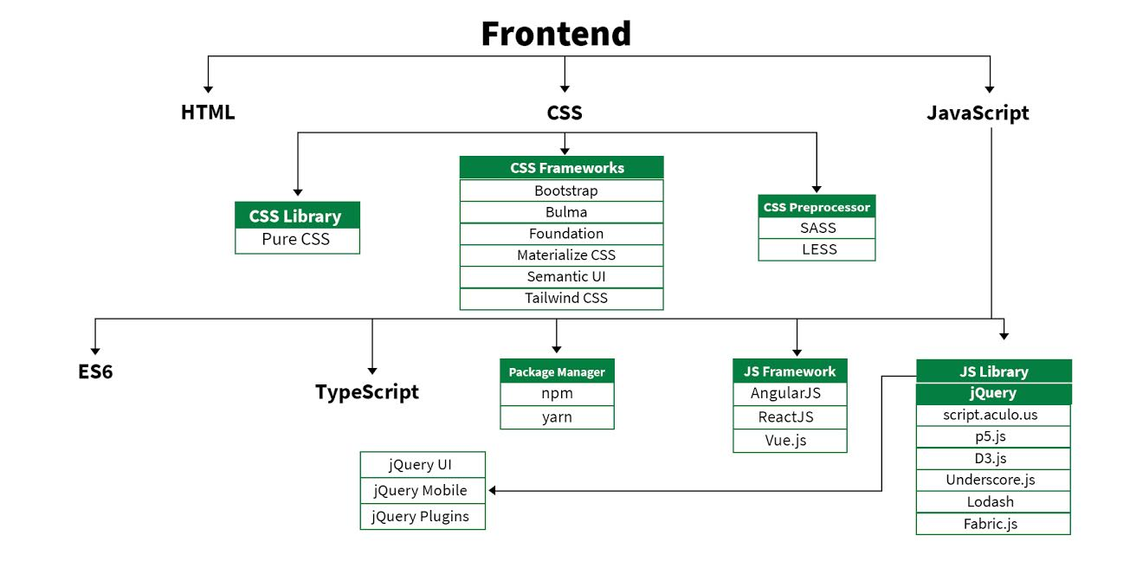
* **Backend Development: The server-side of a website is referred to as the backend. It is the section of the website that visitors are unable to see or interact with. It's the part of the software that doesn't interact with users directly. It is used to organise and store data.**

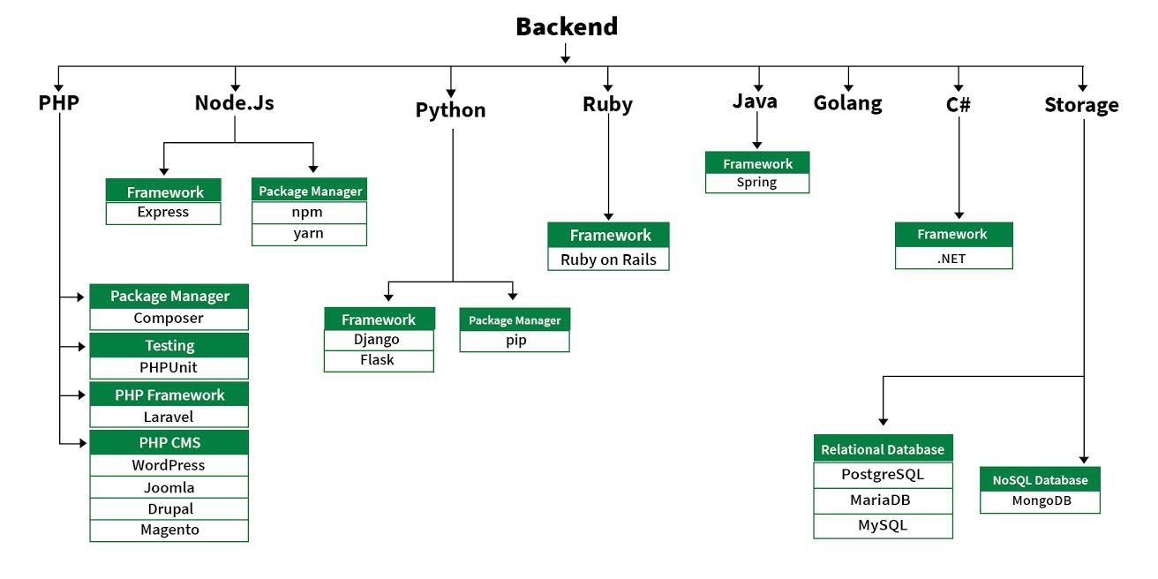

**References:**

* Wikipedia
* [What is a Browser?](https://www.youtube.com/watch?v=o4MwTvtyrUQ) (on YouTube) 30 April 2009. Less than 8% of people who were interviewed on this day knew what a browser was.
* <https://www.geeksforgeeks.org/>

**Images:**

